Official league roster - Soccer
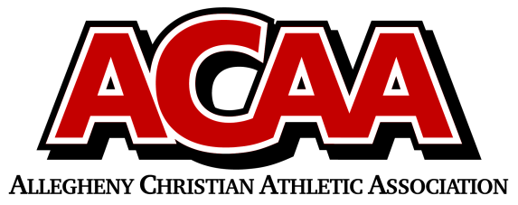

School Name: Blair County Christian
Team Colors: Green and White
Overall Wins ___ Losses ____ Ties ___
ACAA Wins ___ Losses ____ Ties ___ OPPONENT: __________________________
Date: _________
Number | Name | Year | Position | Homeschool
22 | Brad Maretich | 12 | Defense
0/15 | Aidyn Lundy | 11 | Goalie/Def
2 | Jon Marucci | 11 | Defense
9 | Julian Sponsler | 11 | Defense
23 | Arian Lundy | 10 | Defense
3 | Silas Marucci | 10 | Forward
21 | Sayge O’Donnell | 10 | Goalie/Def
11 | Isaiah Snyder | 10 | Forward | X
14 | Blake Grissinger | 9 | Forward | X
16 | Lincoln Brehm | 8 | Midfield
20 | Devon Hewitt | 8 | Defense
18 | Gabe Lundy | 8 | Midfield | X
5 | Donny Shepherd | 8 | Midfield
8 | Hayden Snyder | 8 | Forward
13 | Tucker Shoeman | 7 | Defense
7 | Wesley Trogen | 7 | Defense

Head Coach: Dave Huston
Asst. coach: Davis Dull
Asst. coach: Harrison Hollis
Asst. coach: Aaron Winters

Official ACAA League Team Roster. to be submitted to the scorer’s table before each game.

